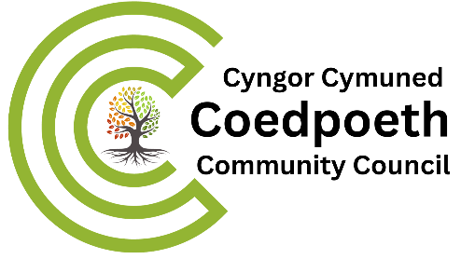

12th June 2024

Dear Councillor
You are invited to attend Coedpoeth Staffing Committee meeting to be held in the Old Carnegie Library, Park Road Coedpoeth LL11 3TD at 9.30am on Monday 17th June 2024.
Yours sincerely
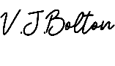
Vicky Bolton (Clerk)
A G E N D A
- APOLOGIES

- DECLARATIONS OF INTEREST

- MINUTES
None available

- FUTURE STAFFING LEVELS
  - Hall

- STAFF APPRAISALS
  - Process – measures – performance – job description
  - Frequency

- TRAINING
  - Handbook
  - Online

- URGENT MATTERS –
Notice of items that should be considered at the meeting as a matter of urgency pursuant to Section 100B (4b) of LGA 1972.
- XXXXXXX
- EXCLUSION OF PUBLIC AND PRESS
To exclude Public and Press (Admissions to Meetings) Act 1960 and in accordance with provisions of Schedule 12A Local Government Act 1972 during the following items:

