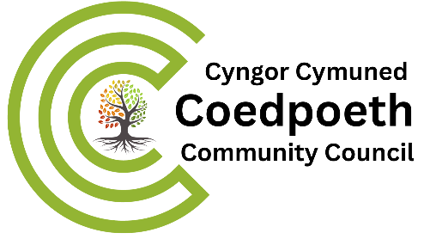

2nd May 2024

Dear Councillor
You are invited to attend Coedpoeth COMMUNITY PLANNING Committee meeting to be held in the Old Carnegie Library, Park Road Coedpoeth LL11 3TD at 7pm on Wednesday 8th May 2024.
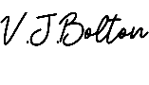
Yours sincerely
Vicky Bolton (Clerk)
………………………
A G E N D A
- APOLOGIES

- DECLARATIONS OF INTEREST

- MINUTES – 27th March 2024
- Copy attached

- COUNCILLORS COMMUNICATIONS

- ANNUAL REPORT

- COMMUNITY AGENT
- Report and communication

- CHRISTMAS EVENTS AND LIGHTS
  - Schools
  - Other groups
  - Location – Hall, Car park
  - Date /Time

- URGENT MATTERS –
Notice of items that should be considered at the meeting as a matter of urgency pursuant to Section 100B (4b) of LGA 1972.
- XXXXXXX
- EXCLUSION OF PUBLIC AND PRESS To exclude Public and Press (Admissions to Meetings) Act 1960 and in accordance with provisions of Schedule 12A Local Government Act 1972 during the following items:

