CYNGOR CYMUNDOL COEDPOETH COMMUNITY COUNCIL

31st August 2023

Dear Councillor
You are invited to attend Coedpoeth Full Council meeting to be held in the Old Carnegie Library, Park Road Coedpoeth LL11 3TD at 7.00pm on Tuesday 5th September 2023.
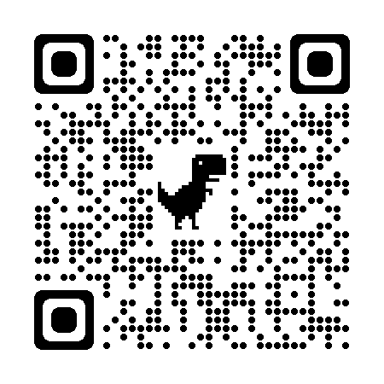
Members of the public welcome.
Yours sincerely Zoom QR Code:

Vicky Bolton (Clerk)
Zoom Link to attend meeting:
https://us06web.zoom.us/meeting/register/tZwkf-ypqz8oH9AM9wW5H97_hmJhS1KiyC4G
………………………
A G E N D A

- APOLOGIES

- DECLARATIONS OF INTEREST

- PUBLIC PARTICIPATION

- MINUTES
- Full Council 01.08.2023 - copy attached

- CHAIRMAN’S COMMUNICATIONS

- COUNCILLORS COMMUNICATIONS

- WREXHAM COUNTY BOROUGH COUNCILLORS – COEDPOETH
To receive verbal report and updates

- CLERK’S REPORT – to follow: To include
- Previous Minute Actions
- Photos for Website – Councillors
- Audit information
- Architect – Steve Jones – Parish Hall
- Prosperous Communities Funding – Cemetery and Toilets

- PLANNING APPLICATION
  - P/2023/0163 Rhos Berse Road
  - P/2023/0506 The Barn, Higher Berse, Higher Berse Road
  - Printed copy of all documents available at office prior to meeting for those unable to view online.

- FINANCIAL REPORTS
- August Payments Schedule - copy attached
- Payroll Report August– copy attached
- Financial Statement at 31/08/23 - copy attached

- LOGO – deferred from last meeting
  - Accessibility
  - Digital use for website etc – clarity
  - Copy of updated logo including Welsh and English wording attached

- POLICIES – to approve
  - Modern Slavery and Human Trafficking Policy – copy attached
  - Whistleblowing and Confidential Reporting Policy – copy attached
  - Environment and Sustainability Policy – copy attached

- URGENT MATTERS –
Notice of items that should be considered at the meeting as a matter of urgency pursuant to Section 100B (4b) of LGA 1972.

- EXCLUSION OF PUBLIC AND PRESS To exclude Public and Press (Admissions to Meetings) Act 1960 and in accordance with provisions of Schedule 12A Local Government Act 1972 during the following items:
  - Staffing Update

To:
All Coedpoeth Community Councillors
Wrexham County Councillors
Coedpoeth Noticeboard and Digitally

