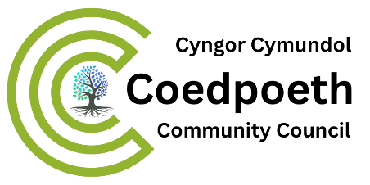

26th September 2023

Dear Councillor
You are invited to attend Coedpoeth Full Council meeting to be held in the Old Carnegie Library, Park Road Coedpoeth LL11 3TD at 7.00pm on Tuesday 3rd October 2023.
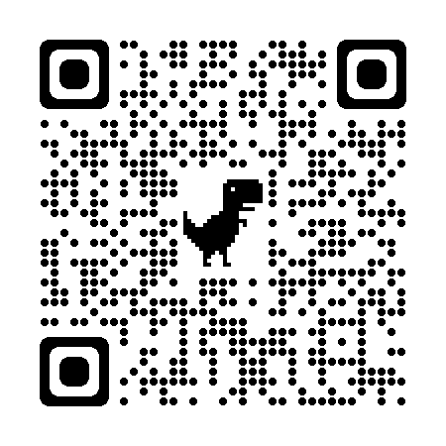
Members of the public welcome.
Yours sincerely Zoom QR Code:

Vicky Bolton (Clerk)
Zoom Link to attend meeting:
https://us06web.zoom.us/meeting/register/tZwkf-ypqz8oH9AM9wW5H97_hmJhS1KiyC4G
A G E N D A

- APOLOGIES

- DECLARATIONS OF INTEREST

- PUBLIC PARTICIPATION

- MINUTES
- Full Council 05.09.2023 - copy attached

- CHAIRMAN’S COMMUNICATIONS

- COUNCILLORS COMMUNICATIONS

- POLICE REPORT – PCSO Steve Howsam attending

- WREXHAM COUNTY BOROUGH COUNCILLORS – COEDPOETH
To receive verbal report and updates

- CLERK’S REPORT –

- BOOKINGS –
  - Till for payments
  - Card payments

- CEMETERY –
  - Committee meeting

- REMEMBRANCE DAY –
  - Wreaths
  - Councillors attending
  - Report from planning meeting

- PLANNING APPLICATION
  - P/2023/0593 – Lower Berse Farm, 1520 Houses
  - P/2023/0607 - Parking and operation of private hire vehicle – Bronant, Heol Maelor

- LICENSING – Change of hours
  - Red Lion, Heol Maelor, Coedpoeth, Wrexham, LL11 3NB
  - Hearing 16th October 2023

- FINANCIAL REPORTS
- MONTH Payments Schedule - copy attached
- Payroll Report – copy attached
- Financial Statement at 30th September 2023- copy attached

- TRAINING PLAN – to approve
  - Allocation of courses

- URGENT MATTERS –
Notice of items that should be considered at the meeting as a matter of urgency pursuant to Section 100B (4b) of LGA 1972.
- Xxxxxxx

- EXCLUSION OF PUBLIC AND PRESS
To exclude Public and Press (Admissions to Meetings) Act 1960 and in accordance with provisions of Schedule 12A Local Government Act 1972 during the following items:

- CIVILITY AND RESPECT PLEDGE – copy attached
  - Statement
  - What it involves
  - Resolution to sign Pledge
  - Resolution to give Clerk permissions

To:
All Coedpoeth Community Councillors
Wrexham County Councillors
Coedpoeth Noticeboard and Digitally

